

Egypt University of Informatics

Computer and Information Systems

Data Analysis Course

The Impact of Match Timing on Game Outcomes in the Egyptian League

Seif ElTohamy 22-101072

Ahmed Gamal 22-101186

Mario Hossam 22-101191

Youssef Nagui 22-101074

Ahmed Adel 22-101252

# Introduction

The analysis of football match outcomes is crucial for teams, coaches, and analysts to improve performance. This report investigates the influence of match timing (afternoon vs. evening) on game outcomes in the Egyptian League. Understanding how match timing affects player performance, scoring, and overall outcomes can provide valuable insights for scheduling and strategy formulation.

# Research Question:

Does the timing of football matches (afternoon vs. evening) have a significant impact on the outcomes in terms of scores and winners in the Egyptian League?

# Hypothesis:

**Null Hypothesis:** There is no significant difference in the outcomes of matches played in the afternoon versus the evening.

**Alternative Hypothesis:** There is a significant difference in the outcomes of matches played in the afternoon versus the evening.

# Population of Interest:

Football matches in the Egyptian League.

# Sampling Method:

The dataset includes comprehensive league data for multiple seasons, representing a complete census of the league rather than a sample.

# Collected Data/Dataset:

The dataset includes annual performance data for teams in the Egyptian Premier League from with the following columns.

* Match Day: The match day within the season
* Date: The date the match was played
* Referee: The referee of the match
* Time: The time the match was played
* Home Team: The home team
* Away Team: The away team
* Yellow Home: Number of yellow cards issued to the home team
* Yellow Away: Number of yellow cards issued to the away team
* 2nd Yellow Home: Number of second yellow cards issued to the home team
* 2nd Yellow Away: Number of second yellow cards issued to the away team
* Red Home: Number of red cards issued to the home team
* Red Away: Number of red cards issued to the away team
* Half Time: The half-time score
* Full Time: The full-time score
* Winner: Outcome of the match (Home Win, Away Win, Draw).

# Analysis:

First, we constructed a bar chart that visualizes the distribution of matches played in the afternoon versus the evening in the Egyptian Premier League.

The x-axis represents the time of day (Afternoon or Evening) while the y-axis represents the number of matches.

As observed in the chart, the number of matches is roughly equal between afternoon and evening, providing a balanced dataset for comparison.

This distribution ensures that any observed differences in subsequent analyses can be attributed to the time of day rather than an imbalance in the number of matches.

|  |
| --- |
|  |
|  |

Next, we analyzed the goals scored during afternoon and evening matches by constructing bar charts that display the average total goals, home goals, and away goals.

The x-axis represents the time of day while the y-axis represents the average goals scored.

Evening matches show a slightly higher average total goals compared to afternoon matches. Home and away teams also score more on average during evening matches.

The increased scoring in the evening suggests that players might be more energetic or that evening conditions are more conducive to scoring.

|  |
| --- |
|  |
|  |

We then examined the match outcomes (win, draw, lose) based on the time of day by creating a stacked bar chart.

The x-axis represents the time of day while the y-axis represents the number of matches, with different colors indicating home win, away win or draw.

Afternoon matches tend to have a higher proportion of draws compared to evening matches.

The time of day appears to have an impact on match outcomes, with afternoon matches showing a higher likelihood of ending in a draw.

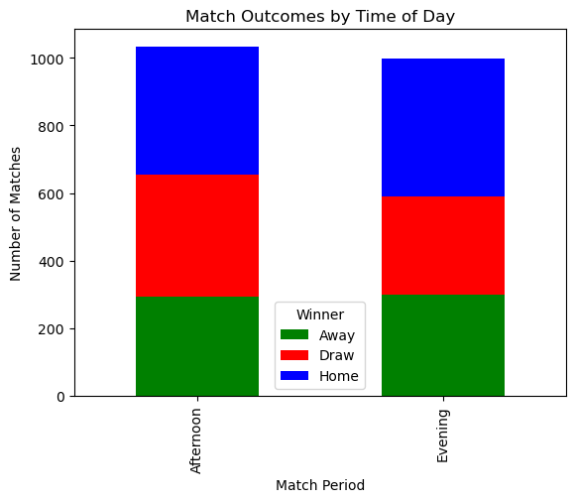

To understand the influence of disciplinary actions, we analyzed the number of yellow and red cards issued during afternoon and evening matches.

We created bar charts to visualize the average number of yellow and red cards issued by time of day.

The number of yellow cards issued is consistent across both time periods.

Matches played in the afternoon tend to have more red cards issued compared to evening matches

The increase in red cards during afternoon matches might indicate a higher level of aggression or stricter refereeing during these times.

Finally, we categorized matches into thirds of the season

(Beginning, middle, end) and examined the outcomes by time of day for each phase.

Calculation

If the season has n match days:

* Beginning phase: Match Day 1 to Match Day n/3
* Middle phase: Match Day n/3 + 1 to Match Day 2n/3
* End phase: Match Day 2n/3 + 1 to Match Day n

- We couldn’t view any insights or trends from the bar chart so we'll prove it statistically using chi-Squared test of independence for each phase

- The season usually starts from October and ends in July

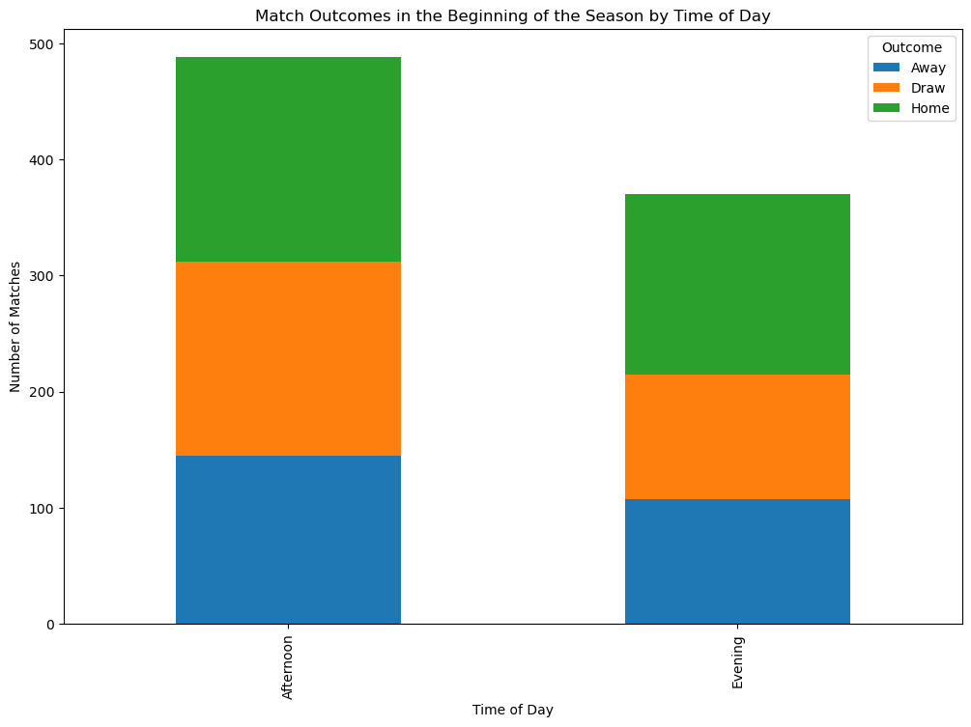

# Hypothesis Testing Steps

1. **T-Test for Average Goals**

We performed a T-test to compare the average total goals scored during afternoon vs. evening matches.

The null hypothesis states that there is no significant difference in the average goals scored between these periods.

Reject the null hypothesis: There is a significant difference in average goals between afternoon and evening matches.

* T-Statistic: -2.3355644184217743
* P-Value: 0.019611275642676045

Conclusion: The p-value is less than 0.05, we reject the null hypothesis and conclude that there is a significant difference in average goals between afternoon and evening matches.

**2. Chi-Squared Test for Match Outcomes**

We performed a Chi-squared test to examine if the distribution of match outcomes (win, lose, draw) differs between afternoon and evening matches.

The null hypothesis states that match outcomes are independent of the time of day.

* Chi-Squared Statistic: 7.3165178473606
* P-Value: 0.025777354019643678

Conclusion: If the p-value is less than 0.05, we reject the null hypothesis and conclude that match outcomes are significantly influenced by the time of day. Otherwise, we fail to reject the null hypothesis.

# Conclusion

Our analysis indicates that match timing does have an impact on game outcomes in the Egyptian League.

Evening matches tend to have higher average goals scored and a higher proportion of draws compared to afternoon matches.

The hypothesis tests confirmed that the differences in average goals and match outcomes between afternoon and evening matches are statistically significant.

These insights can help teams and analysts understand how match timing affects performance and outcomes, potentially guiding scheduling and strategic decisions.

# Any potential issues

The analysis assumes that external factors such as weather, player condition, and team strategies are equally distributed across afternoon and evening matches, which may not always be the case.

The dataset might not account for all possible variables that could influence match outcomes, such as specific player performances or tactical decisions made by coaches.